Generative AI HW2 電機四 4111064113 白舜文
I . Problem Description
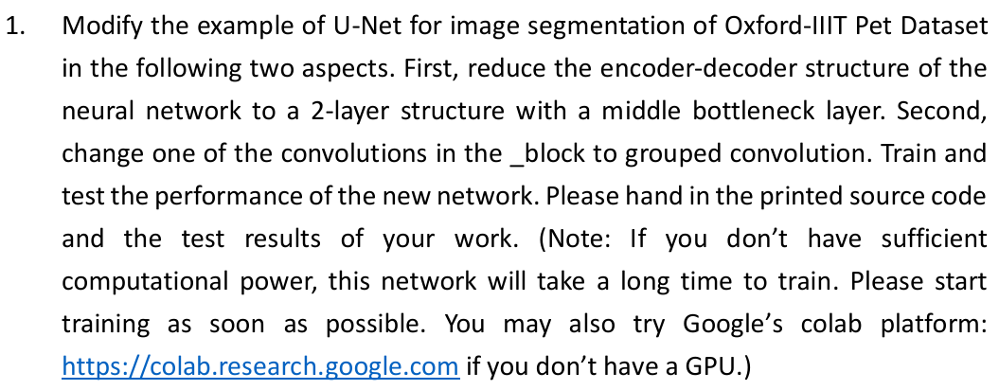
2-layer structure with a middle bottleneck layer:
class UNet(nn.Module):
def __init__(self, in_channels=3, out_channels=3, init_features=64):
super(UNet, self).__init__()
features = init_features
self.encoder1 = UNet._block(in_channels, features, name="enc1")
self.pool1 = nn.MaxPool2d(kernel_size=2, stride=2)
self.encoder2 = UNet._block(features, features * 2, name="enc2")
self.pool2 = nn.MaxPool2d(kernel_size=2, stride=2)
self.bottleneck = UNet._block(features * 2, features * 4, name="bottleneck")
self.upconv2 = nn.ConvTranspose2d(features * 4, features * 2, kernel_size=2, stride=2)
self.decoder2 = UNet._block((features * 2) * 2, features * 2, name="dec2")
self.upconv1 = nn.ConvTranspose2d(features * 2, features, kernel_size=2, stride=2)
self.decoder1 = UNet._block(features * 2, features, name="dec1")
self.conv = nn.Conv2d(in_channels=features, out_channels=out_channels, kernel_size=1)
def forward(self, x):
enc1 = self.encoder1(x)
enc2 = self.encoder2(self.pool1(enc1))
bottleneck = self.bottleneck(self.pool2(enc2))
dec2 = self.upconv2(bottleneck)
dec2 = torch.cat((dec2, enc2), dim=1)
dec2 = self.decoder2(dec2)
dec1 = self.upconv1(dec2)
dec1 = torch.cat((dec1, enc1), dim=1)
dec1 = self.decoder1(dec1)
return torch.sigmoid(self.conv(dec1))

change one of the convolutions in the _block to grouped convolution:
def _block(in_channels, features, name):
group_val = 8 if in_channels % 8 == 0 else 1
return nn.Sequential(
OrderedDict(
[
(
name + "conv1",
nn.Conv2d(
in_channels=in_channels,
out_channels=features,
kernel_size=3,
padding=1,
bias=False,
groups=group_val
),
),
(name + "norm1", nn.BatchNorm2d(num_features=features)),
(name + "relu1", nn.ReLU(inplace=True)),
(
name + "conv2",
nn.Conv2d(
in_channels=features,
out_channels=features,
kernel_size=3,
padding=1,
bias=False,
),
),
(name + "norm2", nn.BatchNorm2d(num_features=features)),
(name + "relu2", nn.ReLU(inplace=True)),
]
)
)

II. Training result
criterion = nn.CrossEntropyLoss(reduction='mean')
optimizer = torch.optim.Adam(model.parameters(), lr=0.001)

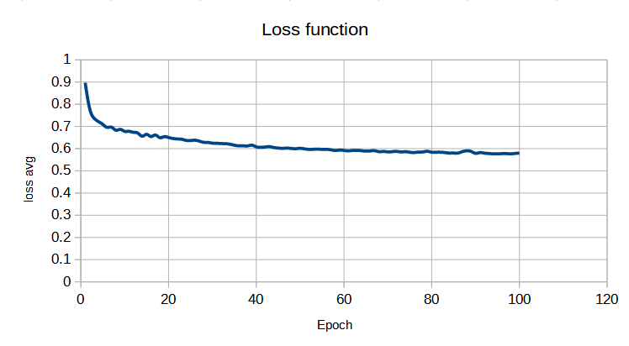

Environment: C:\AI\venv\Scripts\python.exe C:\AI\unet+segnet\unet.py
Epoch: 01, Batch 0, Loss: 1.0682 loss average: 0.8969
Batch 10, Loss: 0.9419
Batch 20, Loss: 0.8881
Batch 30, Loss: 0.8563
Batch 40, Loss: 0.8152
Batch 50, Loss: 0.8116
Epoch: 10, Batch 0, Loss: 0.6688 loss average: 0.6779
Batch 10, Loss: 0.6852
Batch 20, Loss: 0.6793
Batch 30, Loss: 0.6745
Batch 40, Loss: 0.6722
Batch 50, Loss: 0.6871
Epoch: 20, Batch 0, Loss: 0.6444 loss average: 0.6502
Batch 10, Loss: 0.6543
Batch 20, Loss: 0.6508
Batch 30, Loss: 0.6589
Batch 40, Loss: 0.6361
Batch 50, Loss: 0.6569
Epoch: 30, Batch 0, Loss: 0.6262 loss average: 0.6247
Batch 10, Loss: 0.6265
Batch 20, Loss: 0.6183
Batch 30, Loss: 0.6218
Batch 40, Loss: 0.6210
Batch 50, Loss: 0.6345
Epoch: 40, Batch 0, Loss: 0.6121 loss average: 0.6082
Batch 10, Loss: 0.6105
Batch 20, Loss: 0.6068
Batch 30, Loss: 0.6050
Batch 40, Loss: 0.6058
Batch 50, Loss: 0.6092
Epoch: 50, Batch 0, Loss: 0.6013 loss average: 0.6013
Batch 10, Loss: 0.6072
Batch 20, Loss: 0.5960
Batch 30, Loss: 0.6018
Batch 40, Loss: 0.5994
Batch 50, Loss: 0.6021
Epoch: 60, Batch 0, Loss: 0.5911 loss average: 0.5918
Batch 10, Loss: 0.5910
Batch 20, Loss: 0.5963
Batch 30, Loss: 0.5909
Batch 40, Loss: 0.5891
Batch 50, Loss: 0.5923
Epoch: 70, Batch 0, Loss: 0.5815 loss average: 0.5854
Batch 10, Loss: 0.5837
Batch 20, Loss: 0.5871
Batch 30, Loss: 0.5865
Batch 40, Loss: 0.5890
Batch 50, Loss: 0.5843
Epoch: 80, Batch 0, Loss: 0.5837 loss average: 0.5838
Batch 10, Loss: 0.5849
Batch 20, Loss: 0.5841
Batch 30, Loss: 0.5820
Batch 40, Loss: 0.5844
Batch 50, Loss: 0.5835
Epoch: 90, Batch 0, Loss: 0.5802 loss average: 0.5790
Batch 10, Loss: 0.5788
Batch 20, Loss: 0.5793
Batch 30, Loss: 0.5805
Batch 40, Loss: 0.5787
Batch 50, Loss: 0.5765
Epoch: 100, Batch 0, Loss: 0.5763 loss average: 0.5798
Batch 10, Loss: 0.5762
Batch 20, Loss: 0.5791
Batch 30, Loss: 0.5809
Batch 40, Loss: 0.5838
Batch 50, Loss: 0.5826

During training, I found that there’re no plt.figure() functions inside like HW1, so I used excel to draw the loss function figure instead.
III. Testing for two results
Environment: C:\AI\venv\Scripts\python.exe C:\AI\unet+segnet\unet_test.py
device: cuda
100.0%
100.0%
The Model has 1.22M parameters

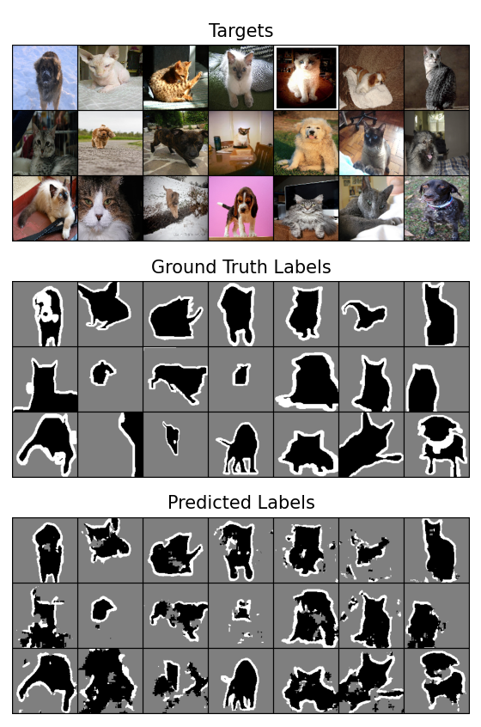

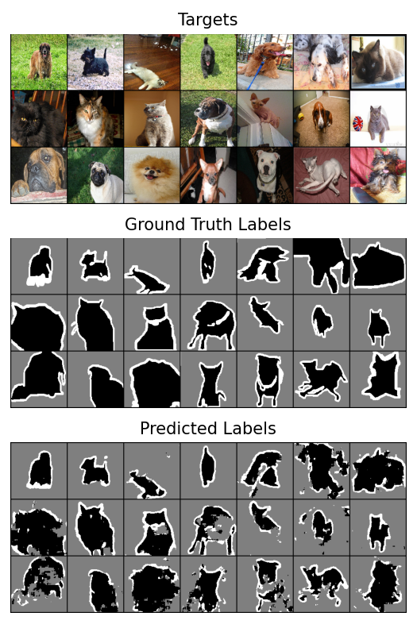

IV. Source code
1. unet.py:
import torch
from torch import nn
import torchvision
import torchvision.transforms as T
from collections import OrderedDict
# https://github.com/mateuszbuda/brain-segmentation-pytorch
def tensor_trimap(t):
x = t * 255
x = x.to(torch.long)
x = x - 1
return x
class UNet(nn.Module):
def __init__(self, in_channels=3, out_channels=3, init_features=64):
super(UNet, self).__init__()
features = init_features
self.encoder1 = UNet._block(in_channels, features, name="enc1")
self.pool1 = nn.MaxPool2d(kernel_size=2, stride=2)
self.encoder2 = UNet._block(features, features * 2, name="enc2")
self.pool2 = nn.MaxPool2d(kernel_size=2, stride=2)
# self.encoder3 = UNet._block(features * 2, features * 4, name="enc3")
# self.pool3 = nn.MaxPool2d(kernel_size=2, stride=2)
# self.bottleneck = UNet._block(features * 4, features * 8, name="bottleneck")
self.bottleneck = UNet._block(features * 2, features * 4, name="bottleneck")
self.upconv2 = nn.ConvTranspose2d(
features * 4, features * 2, kernel_size=2, stride=2
)
self.decoder2 = UNet._block((features * 2) * 2, features * 2, name="dec2")
self.upconv1 = nn.ConvTranspose2d(
features * 2, features, kernel_size=2, stride=2
)
self.decoder1 = UNet._block(features * 2, features, name="dec1")
# self.upconv1 = nn.ConvTranspose2d(
#features * 2, features, kernel_size=2, stride=2
#)
#self.decoder1 = UNet._block(features * 2, features, name="dec1")
self.conv = nn.Conv2d(
in_channels=features, out_channels=out_channels, kernel_size=1
)
def forward(self, x):
enc1 = self.encoder1(x)
enc2 = self.encoder2(self.pool1(enc1))
# enc3 = self.encoder3(self.pool2(enc2))
bottleneck = self.bottleneck(self.pool2(enc2))
# dec3 = self.upconv3(bottleneck)
# dec3 = torch.cat((dec3, enc3), dim=1)
# dec3 = self.decoder3(dec3)
dec2 = self.upconv2(bottleneck)
dec2 = torch.cat((dec2, enc2), dim=1)
dec2 = self.decoder2(dec2)
dec1 = self.upconv1(dec2)
dec1 = torch.cat((dec1, enc1), dim=1)
dec1 = self.decoder1(dec1)
return torch.sigmoid(self.conv(dec1))
def _block(in_channels, features, name):
group_val = 8 if in_channels % 8 == 0 else 1
return nn.Sequential(
OrderedDict(
[
(
name + "conv1",
nn.Conv2d(
in_channels=in_channels,
out_channels=features,
kernel_size=3,
padding=1,
bias=False,
groups=group_val
),
),
(name + "norm1", nn.BatchNorm2d(num_features=features)),
(name + "relu1", nn.ReLU(inplace=True)),
(
name + "conv2",
nn.Conv2d(
in_channels=features,
out_channels=features,
kernel_size=3,
padding=1,
bias=False,
),
),
(name + "norm2", nn.BatchNorm2d(num_features=features)),
(name + "relu2", nn.ReLU(inplace=True)),
]
)
)
def train_loop(model, loader, epochs, device):
criterion = nn.CrossEntropyLoss(reduction='mean')
optimizer = torch.optim.Adam(model.parameters(), lr=0.001)
epoch_i, epoch_j = epochs
for i in range(epoch_i, epoch_j):
# print(f"Epoch: {i:02d}, Learning Rate: {optimizer.param_groups[0]['lr']}")
print(f"Epoch: {i:02d}")
running_loss = 0.0
# running_samples = 0
for batch_idx, (inputs, targets) in enumerate(loader, 0):
inputs = inputs.to(device)
targets = targets.to(device)
optimizer.zero_grad()
outputs = model(inputs)
# targets = targets.squeeze(dim=1)
# loss = criterion(outputs, targets)
loss = criterion(outputs, targets.squeeze(dim=1))
loss.backward()
optimizer.step()
# running_samples += targets.size(0)
running_loss += loss.item()
if batch_idx % 10 == 0:
print(f"Batch {batch_idx}, Loss: {loss.item():.4f}")
# print("Trained {} samples, Loss: {:.4f}".format(running_samples, running_loss / (batch_idx+1)))
if torch.cuda.is_available():
device = torch.device("cuda")
else:
device = torch.device("cpu")
print('device:', device)
transforms = T.Compose([T.ToTensor(), T.Resize((128, 128), interpolation=T.InterpolationMode.NEAREST)])
target_transforms = T.Compose([T.ToTensor(), T.Resize((128, 128), interpolation=T.InterpolationMode.NEAREST), T.Lambda(tensor_trimap)])
pets_train = torchvision.datasets.OxfordIIITPet(root="datasets/OxfordPets/train/", split="trainval", target_types="segmentation",
download=True, transform=transforms, target_transform=target_transforms)
pets_train_loader = torch.utils.data.DataLoader(pets_train, batch_size=64, shuffle=True)
model = UNet()
model = model.to(device)
model.train()
train_loop(model, pets_train_loader, (1, 101), device)
torch.save(model.state_dict(), 'unet.pth')

2. unet_test.py:
import torch
from torch import nn
import torchvision
import torchvision.transforms as T
from collections import OrderedDict
from matplotlib import pyplot as plt
t2img = T.ToPILImage()
def tensor_trimap(t):
x = t * 255
x = x.to(torch.long)
x = x - 1
return x
class UNet(nn.Module):
def __init__(self, in_channels=3, out_channels=3, init_features=64):
super(UNet, self).__init__()
features = init_features
self.encoder1 = UNet._block(in_channels, features, name="enc1")
self.pool1 = nn.MaxPool2d(kernel_size=2, stride=2)
self.encoder2 = UNet._block(features, features * 2, name="enc2")
self.pool2 = nn.MaxPool2d(kernel_size=2, stride=2)
# self.encoder3 = UNet._block(features * 2, features * 4, name="enc3")
# self.pool3 = nn.MaxPool2d(kernel_size=2, stride=2)
self.bottleneck = UNet._block(features * 2, features * 4, name="bottleneck")
self.upconv2 = nn.ConvTranspose2d(
features * 4, features * 2, kernel_size=2, stride=2
)
self.decoder2 = UNet._block(features * 4, features * 2, name="dec2")
self.upconv1 = nn.ConvTranspose2d(
features * 2, features, kernel_size=2, stride=2
)
self.decoder1 = UNet._block(features * 2, features, name="dec1")
# self.upconv1 = nn.ConvTranspose2d(
# features * 2, features, kernel_size=2, stride=2
# )
# self.decoder1 = UNet._block(features * 2, features, name="dec1")
self.conv = nn.Conv2d(
in_channels=features, out_channels=out_channels, kernel_size=1
)
def forward(self, x):
enc1 = self.encoder1(x)
enc2 = self.encoder2(self.pool1(enc1))
# enc3 = self.encoder3(self.pool2(enc2))
bottleneck = self.bottleneck(self.pool2(enc2))
# dec3 = self.upconv3(bottleneck)
# dec3 = torch.cat((dec3, enc3), dim=1)
# dec3 = self.decoder3(dec3)
dec2 = self.upconv2(bottleneck)
dec2 = torch.cat((dec2, enc2), dim=1)
dec2 = self.decoder2(dec2)
dec1 = self.upconv1(dec2)
dec1 = torch.cat((dec1, enc1), dim=1)
dec1 = self.decoder1(dec1)
return torch.sigmoid(self.conv(dec1))
def _block(in_channels, features, name):
group_val = 8 if in_channels % 8 == 0 else 1
return nn.Sequential(
OrderedDict(
[
(
name + "conv1",
nn.Conv2d(
in_channels=in_channels,
out_channels=features,
kernel_size=3,
padding=1,
bias=False,
groups=group_val
),
),
(name + "norm1", nn.BatchNorm2d(num_features=features)),
(name + "relu1", nn.ReLU(inplace=True)),
(
name + "conv2",
nn.Conv2d(
in_channels=features,
out_channels=features,
kernel_size=3,
padding=1,
bias=False,
),
),
(name + "norm2", nn.BatchNorm2d(num_features=features)),
(name + "relu2", nn.ReLU(inplace=True)),
]
)
)
if torch.cuda.is_available():
device = torch.device("cuda")
else:
device = torch.device("cpu")
print('device:', device)
transforms = T.Compose([T.ToTensor(), T.Resize((128, 128), interpolation=T.InterpolationMode.NEAREST)])
target_transforms = T.Compose([T.ToTensor(), T.Resize((128, 128), interpolation=T.InterpolationMode.NEAREST), T.Lambda(tensor_trimap)])
pets_test = torchvision.datasets.OxfordIIITPet(root="datasets/OxfordPets/test/", split="test", target_types="segmentation",
download=True, transform=transforms, target_transform=target_transforms)
pets_test_loader = torch.utils.data.DataLoader(pets_test, batch_size=21, shuffle=True)
model = UNet()
model.load_state_dict(torch.load('unet.pth',weights_only=True))
model = model.to(device)
model.eval()
with torch.inference_mode():
total_params = sum(param.numel() for param in model.parameters())
print(f"The Model has {total_params/1e6:.2f}M parameters")
(inputs, targets) = next(iter(pets_test_loader))
inputs = inputs.to(device)
targets = targets.to(device)
predictions = model(inputs)
# pred = nn.Softmax(dim=1)(predictions)
pred_labels = predictions.argmax(dim=1)
pred_labels = pred_labels.unsqueeze(1)
pred_mask = pred_labels.to(torch.float)
fig = plt.figure(figsize=(10, 12))
fig.add_subplot(3, 1, 1)
plt.imshow(t2img(torchvision.utils.make_grid(inputs, nrow=7)))
plt.axis('off')
plt.title("Targets")
fig.add_subplot(3, 1, 2)
plt.imshow(t2img(torchvision.utils.make_grid(targets.float() / 2.0, nrow=7)))
plt.axis('off')
plt.title("Ground Truth Labels")
fig.add_subplot(3, 1, 3)
plt.imshow(t2img(torchvision.utils.make_grid(pred_mask / 2.0, nrow=7)))
plt.axis('off')
plt.title("Predicted Labels")
plt.show()

